YOS Understanding Documents

Overview
YOS - Yard Operations System (EAI – 3535360, Tier 3)
YOS is an internal developed Solution for managing hub and yard operations at Express hubs in Europe.
- YOS application is built on a micro service architecture.
- The configurations required are maintained in GIT repository and are fetched using a Spring cloud config server.
- The client is a browser running on angular application.
- This angular application is bundled with a springboot web app.
- All the requests from the client are passed on to the Spring Cloud API gateway.
- This API gateway will route the request to the specific micro services based on the url pattern.
- All the micro services are registered to the Eureka Server.
- All the micro services will register with the Eureka server and eureka server has the details for each micro service.
- Here is the user interface of Eureka server.
- 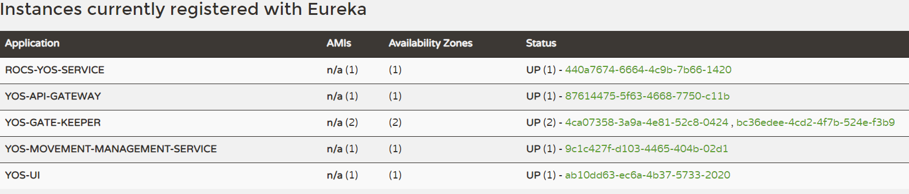
- The communication between the micro services can be achieved using the Eureka Server.
- Environment specific configuration are part of the environment (PCF).
- Auto Scaling of the micro services is done in PCF through configuration.

YOS UI Application
Link - https://yos.apps.tnt.com/login
Screen to select location before login to the application.
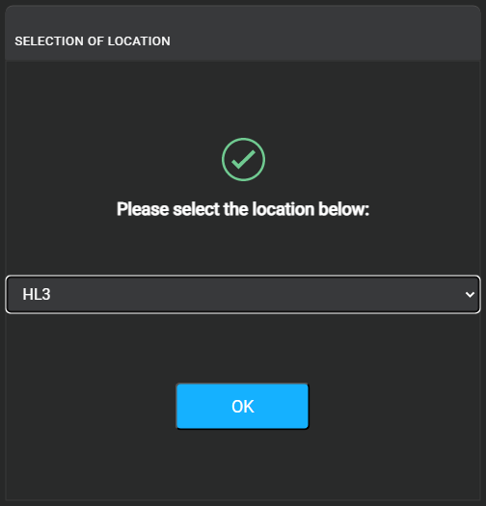

YOS Modules
There are 6 modules as below for every location, which helps to manage the application services smoothly. Each module has separate screen and operation in one screen will get reflected instantly to other screens. Due to this real time data, manual refresh is not required.
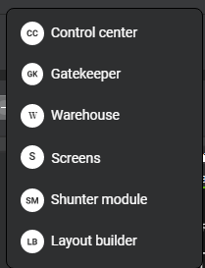
- Gate Keeper

Main task of Gatekeeper involves,
- Arrives the unit.
- Depart the unit.
- Parking details for the truck
Every truck comes to the Hub should pass through this module where security check happens. Truck related details will be verified using the paper works. If all verified fine post scanning the papers, arrivals of the trucks will be done, and parking details will be shared.
These data for Gate keeper comes from ROCS through IBIS application. Gate keeper can raise concerns with Control room if any data issues found. Gate keeper can also add Driver and truck details if its missing in the application, which will get verified.

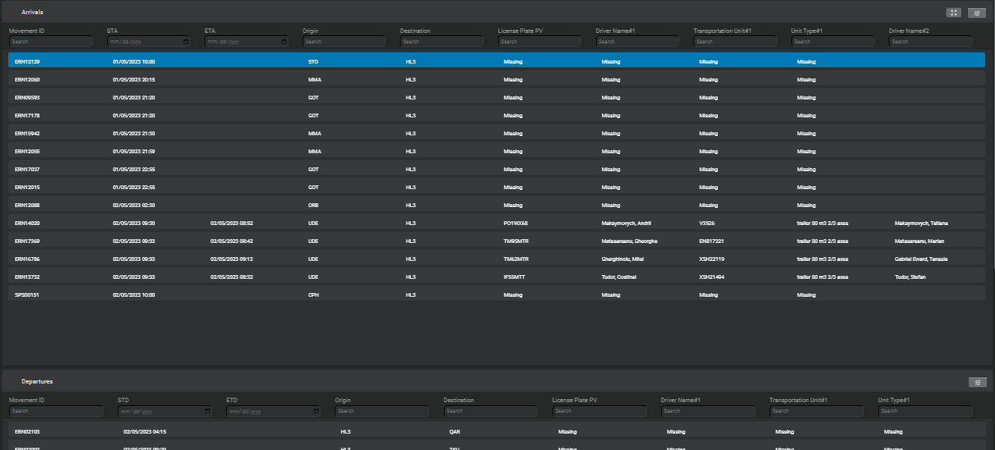

- Hub - Control Center
This team will handle the task managing the YOS application for a location. When the truck entering hub control center guy will drag using the inbound view and assign the door for each truck post security check.
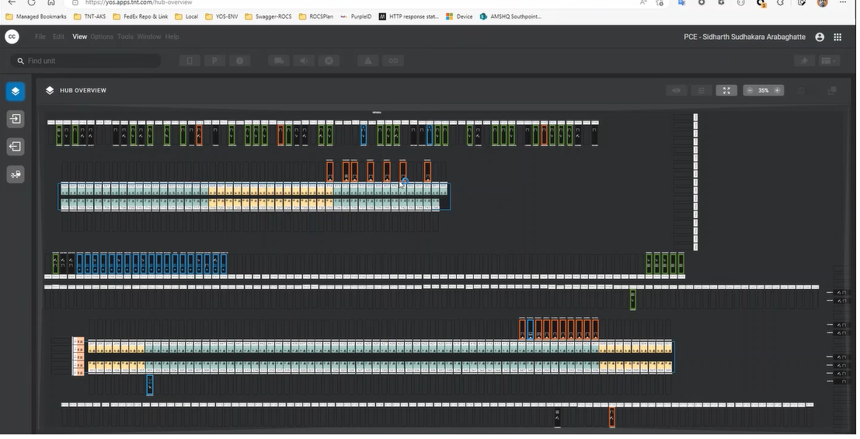

- Warehouse
This provides many screens, Add/Delete or Save the door details for a particular location.
This will be usually managed by application.

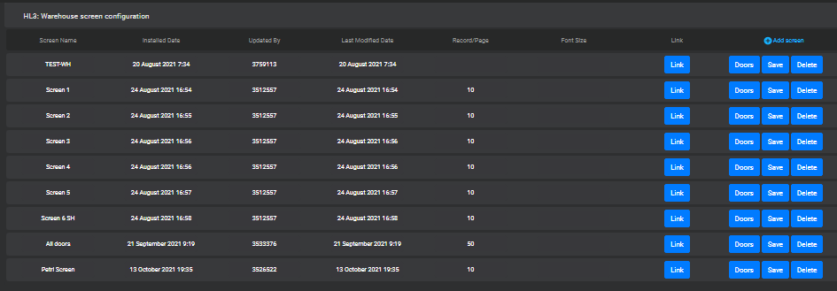

- Screens
Custom screens will be added or managed by user to get quick view on the application side. This can also be shared to a particular group to ease the process.

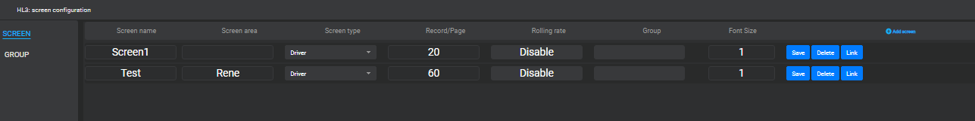

- Shunter Module
- Control center team will assign the task to shunter to move the unit from one door to another after loading/unloading of the package completes.
- Person from Shunter team will accept the task and move the trailer/unit as assigned and update the status completed once task finish.
- Location Confirmation – another important task done by Shunter team.

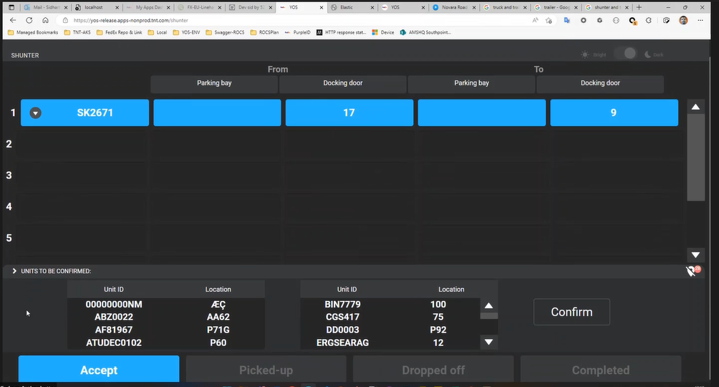

- Layout Builder
This module is to customize the Hub overview screen, action taken by Admin. Helps users to get different perspectives to the application with the customized layout.
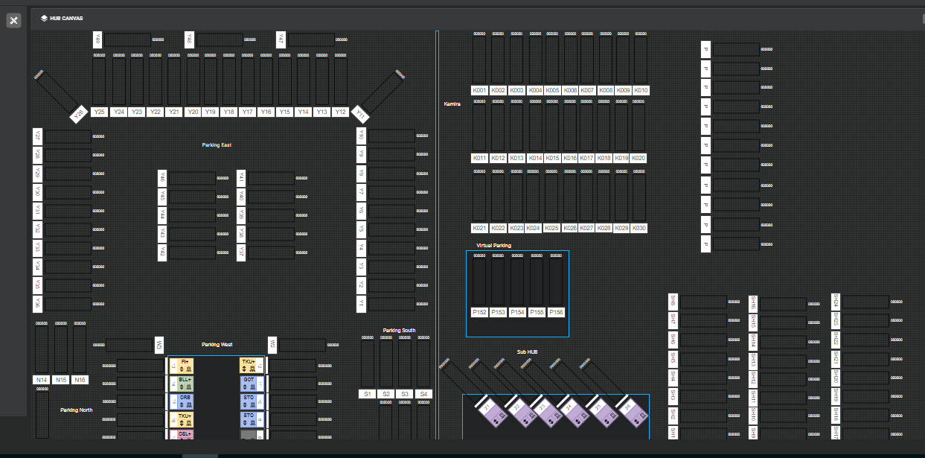

YOS Views
Control center and Gate keeper will have below set of views to get clarity on the current activities which is happening in different modules.
- YOS Hub Overview
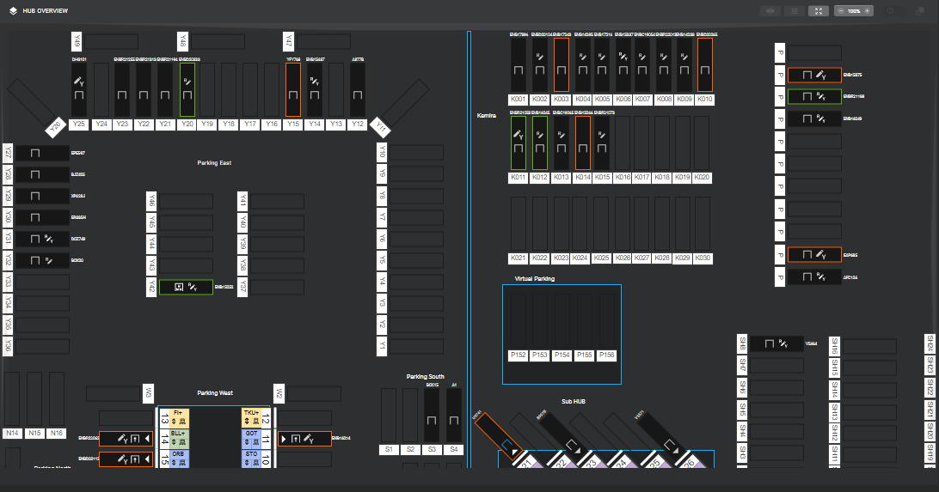

- Inbound View
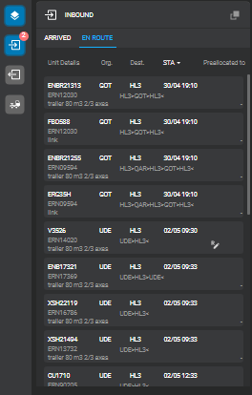
- Outbound View
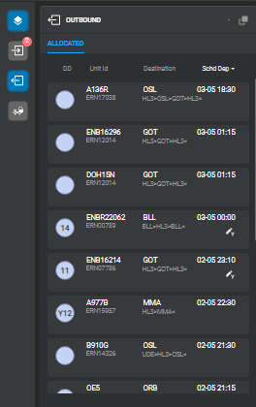
- Shunter View

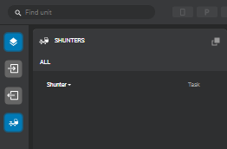

YOS Support Model

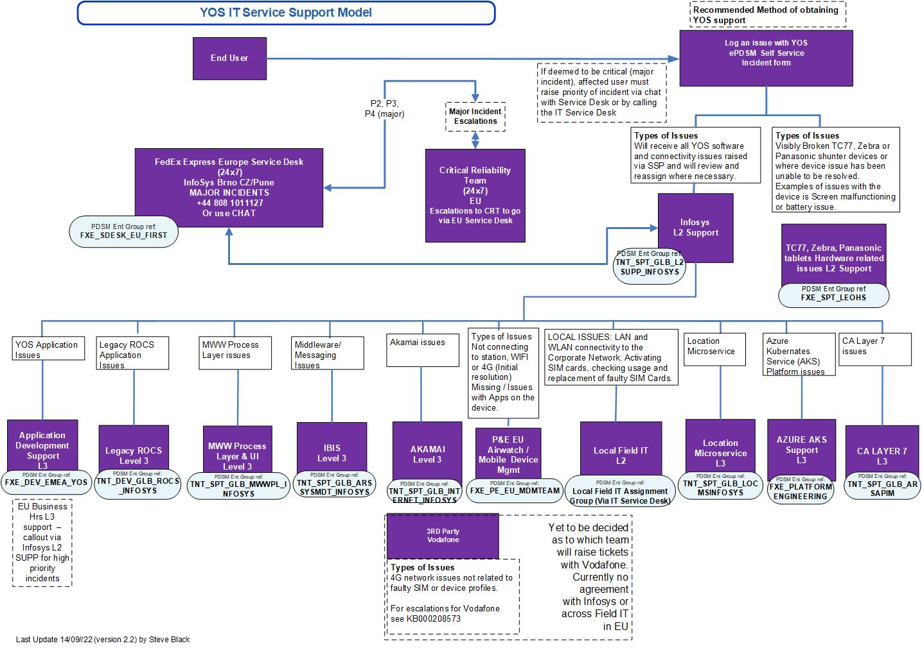
DB Connection Details
To resolve an issue related to data mismatch Application support team must login to DB and do sql CRUD (Create/Select/Update/Delete) operations. DB details as below,
Username: YOS_SCHEMA
Password: yosadmin
JDBC connection String:
jdbc:oracle:thin:@(DESCRIPTION_LIST=(LOAD_BALANCE=off)(FAILOVER=off)(DESCRIPTION=(ADDRESS_LIST=(LOAD_BALANCE=off)(ADDRESS=(PROTOCOL=TCP)(HOST=tntazneurpl108.tntad.fedex.com)(PORT=1522)))(CONNECT_DATA=(SERVICE_NAME=MSZPUPA1.tntad.fedex.com)))(DESCRIPTION=(ADDRESS_LIST=(LOAD_BALANCE=off)(ADDRESS=(PROTOCOL=TCP)(HOST=tntazneurpl109.tntad.fedex.com)(PORT=1522)))(CONNECT_DATA=(SERVICE_NAME=MSZPUPA1.tntad.fedex.com))))

Grafana

When multiple webservices/running in cloud, Grafana tool is configured with each of the webservice. YOS application is developed under microservice architecture. Each service has a set of responsibility for doing that and for each of the service we integrate the Grafana tool. Below are the Grafana Sample screens.
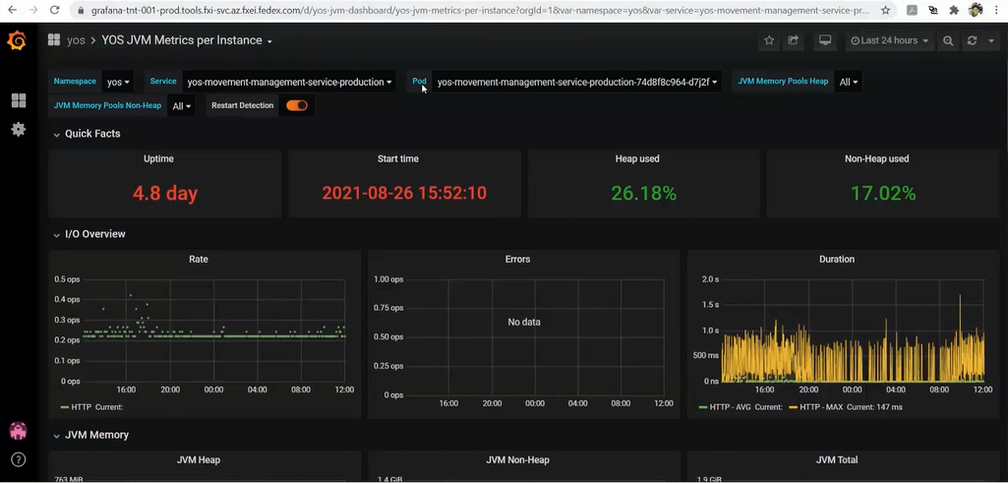

Kibana

Kibana is a proprietary data visualization dashboard software which provides visualization capabilities on top of the content indexed. Users can create bar, line and scatter plots, or pie charts and maps on top of large volumes of data.
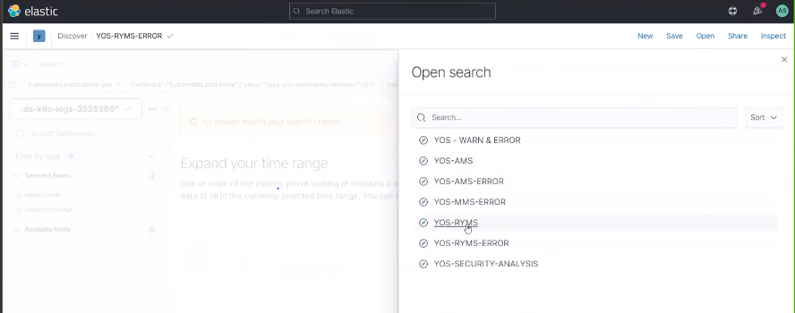
Critical Errors
- Sep 25, 2022 @ 04:00:30.489 rocs-yos-messaging-service-production ERROR Could not refresh JMS Connection for destination 'ECL.TNTCONSDEPART_CREATE_YOS.2' - retrying using FixedBackOff{interval=5000, currentAttempts=3012, maxAttempts=unlimited}. Cause: JMSWMQ0018: Failed to connect to queue manager 'QPDC1GC1' with connection mode 'Clien
Inform IBIS team,

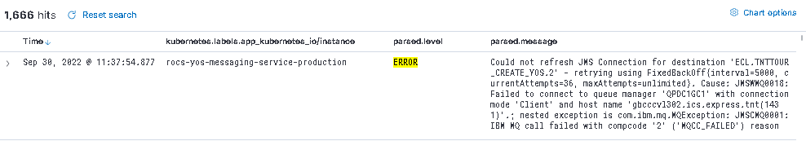

- May 16, 2022 @ 14:06:26.863 yos-warehouse-screen-service-production ERROR HikariPool-1 - Connection is not available, request timed out after 30000ms. – Inform L3 team

Use Cases/Incidents
- YOS/Remove Unit/Unable to action on Unit.
- Some known issues and their required action items

Refences
Saved_KT_Sessions - https://nam11.safelinks.protection.outlook.com/?url=https%3A%2F%2Fmyfedex.sharepoint.com%2F%3Af%3A%2Fr%2Fteams%2FSD-HubStackCC%2FKnowledge%2FYOS%2FTraining%2FRecorded%2520Sessions%3Fcsf%3D1%26web%3D1%26e%3D1sEbph&data=05%7C01%7Crajarama.kaniyoor.osv%40fedex.com%7C59fd02534799409ffb1808daef129831%7Cb945c813dce641f884575a12c2fe15bf%7C0%7C0%7C638085160385185492%7CUnknown%7CTWFpbGZsb3d8eyJWIjoiMC4wLjAwMDAiLCJQIjoiV2luMzIiLCJBTiI6Ik1haWwiLCJXVCI6Mn0%3D%7C3000%7C%7C%7C&sdata=MJ2b6uZhgVyM7VuUD1GDTTFdUq0M2Uu0EE8MkKhW6go%3D&reserved=0

Architecture Diagrams

